Create the following tables, insert data, and generate the queries which are given below:
Tables with Data

Table: Customers
CustomerID | Name | City | JoinDate | CreditLimit
1 | Alice Johnson | New York | 2023-01-15 | 10000
2 | Bob Smith | Los Angeles | 2022-10-10 | 15000
3 | Charlie Brown | Chicago | 2024-05-05 | 8000
4 | David Wilson | New York | 2023-08-20 | 20000
5 | Emma Thomas | Miami | 2023-02-12 | 12000

Table: Orders
OrderID | CustomerID | OrderDate | TotalAmount
101 | 1 | 2024-01-01 | 1200
102 | 3 | 2024-06-15 | 2500
103 | 2 | 2024-03-20 | 1800
104 | 4 | 2024-02-10 | 3000
105 | 1 | 2024-04-05 | 2200
106 | 5 | 2024-05-18 | 3500

Table: Products
ProductID | ProductName | Category | Price
201 | Laptop | Electronics | 1200
202 | Smartphone | Electronics | 800
203 | Office Chair | Furniture | 150
204 | Dining Table | Furniture | 600
205 | Headphones | Electronics | 300
Table: OrderDetails
OrderDetailID | OrderID | ProductID |  | Quantity | UnitPrice
1 | 101 | 201 | 1 |  | 50000
2 | 101 | 202 | 2 |  | 25000
3 | 102 | 203 | 4 |  | 5000
4 | 103 | 204 | 1 |  | 15000
5 | 104 | 205 | 3 |  | 3000
6 | 105 | 201 | 2 |  | 50000
7 | 106 | 202 | 1 |  | 25000

1. Simple Queries
- Retrieve all columns from the Customers table.
select * from t_customers;
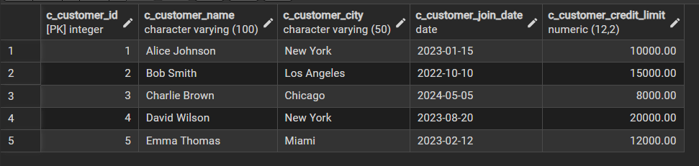
- List all products in the 'Furniture' category.
select * from t_products where c_category = 'Furniture';
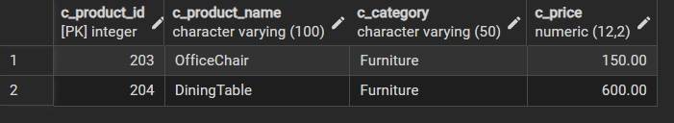
- Display orders where the total amount is greater than ₹3000.
select * from t_orders where c_total_amount > 3000;
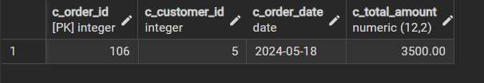
- Find all customers who joined before 2023-06-01.
select * from t_customers where c_customer_join_date < '2023-06-01';
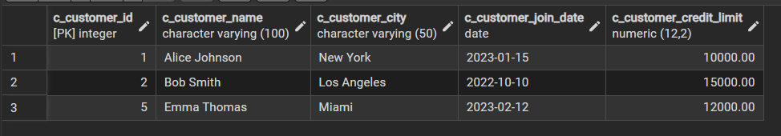
- Retrieve the names and cities of customers who have placed at least one order.
select c.c_customer_name,c.c_customer_city from t_customers c join t_orders o on c.c_customer_id = o.c_customer_id;
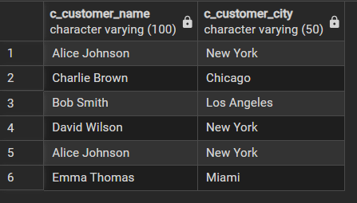

2. IN, LIKE, and Date Functions
- List customers from cities 'Mumbai', 'Delhi', or 'Chennai' using the IN clause.
select * from t_customers where c_customer_city in ('Mumbai','Chennai','Delhi');
- Find product names that contain the word 'Table' using the LIKE keyword.
select * from t_products where c_product_name like '%Table%';

- Retrieve orders placed in the month of April 2024 using a date function.
SELECT * FROM t_orders WHERE DATE_PART('month', c_order_date) = 4 AND DATE_PART('year', c_order_date) = 2024;
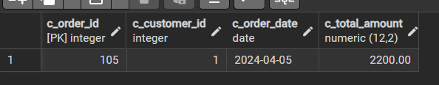
- List products whose price is between ₹5000 and ₹30000 using BETWEEN.
select * from t_products where c_price between 5000 and 30000;

- Find customers whose names start with the letter 'R'.
select * from t_customers where c_customer_name like '%R';


3. Aggregate Functions
- Count the total number of orders placed by each customer using GROUP BY.
SELECT c_customer_id ,COUNT(c_order_id) AS total_orders
FROM t_orders
GROUP BY c_customer_id;
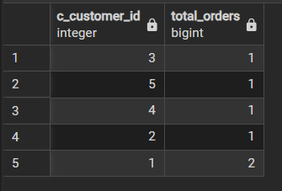
- Find the average price of products in each category.
Select c_category, AVG(c_price) as total_price from t_products group by c_category;
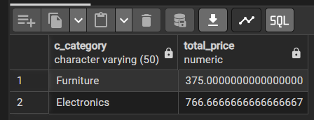
- Retrieve the maximum and minimum order total amounts.
select MAX(c_total_amount)+MIN(c_total_amount) as sum_of_max_min from t_orders;
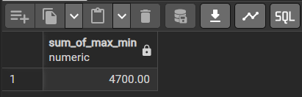
- Compute the total revenue generated from all orders.
select sum(c_total_amount) as total_revenue from t_orders;
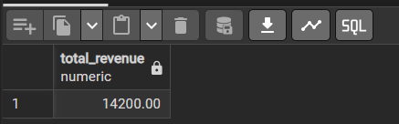
- Find the total number of distinct products ordered.
select count(distinct c_order_id) as distinct_orders from t_order_details;
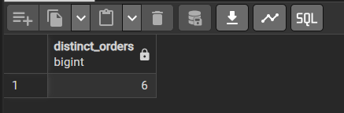
4. GROUP BY, HAVING, and DISTINCT
- List the total number of orders placed by customers who have placed more than 1 order using HAVING.
SELECT c_customer_id, COUNT(c_order_id) AS total_orders
FROM t_orders
GROUP BY c_customer_id
HAVING COUNT(c_order_id) > 1;
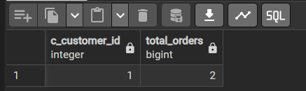
- Retrieve the distinct categories of products available.
SELECT c_customer_id, COUNT(c_order_id) AS total_orders
FROM t_orders
GROUP BY c_customer_id
HAVING COUNT(c_order_id) > 1;
- Display the total revenue generated by each customer, only including those who have generated more than ₹4000 in revenue.
SELECT c.c_customer_name,
SUM(o.c_total_amount) AS total_revenue
FROM t_customers c
JOIN t_orders o
ON c.c_customer_id = o.c_customer_id
GROUP BY c.c_customer_name
HAVING SUM(o.c_total_amount) > 4000;
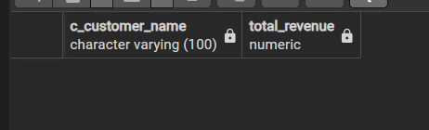
- Count the number of products sold in each category.
SELECT p.c_category,
SUM(od.c_quantity) AS total_products_sold
FROM t_order_details od
JOIN t_products p
ON od.c_product_id = p.c_product_id
GROUP BY p.c_category;
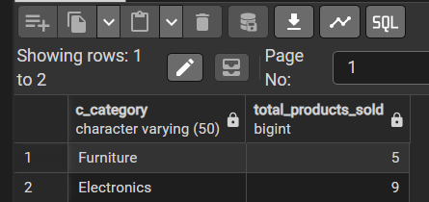
- List distinct cities where customers are located.
SELECT DISTINCT c_customer_city
FROM t_customers;
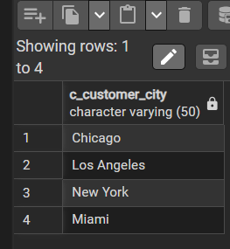

5. ORDER BY (Multi-column)
- Retrieve products ordered by Category in ascending order and Price in descending order.
SELECT p.c_product_name,
p.c_category,
p.c_price
FROM t_products p
JOIN t_order_details od
ON p.c_product_id = od.c_product_id
GROUP BY p.c_product_name, p.c_category, p.c_price
ORDER BY p.c_category ASC, p.c_price DESC;
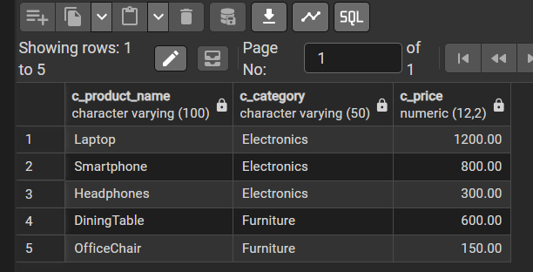
- Display customers sorted by City in ascending order and CreditLimit in descending order.
SELECT c_customer_name,
c_customer_city,
c_customer_credit_limit
FROM t_customers
ORDER BY c_customer_city ASC,
c_customer_credit_limit DESC;
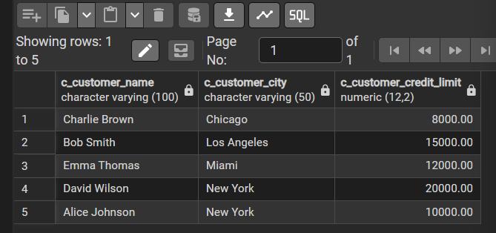
- List orders sorted by OrderDate and TotalAmount.
SELECT c_order_id,
c_customer_id,
c_order_date,
c_total_amount
FROM t_orders
ORDER BY c_order_date ASC,
c_total_amount ASC;
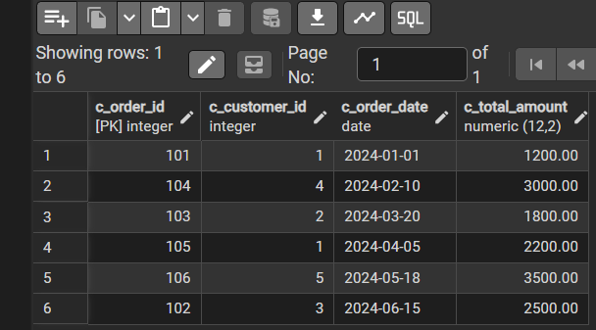
- Find the top 3 most expensive products using ORDER BY and LIMIT.
SELECT c_product_name,
c_category,
c_price
FROM t_products
ORDER BY c_price DESC
LIMIT 3;
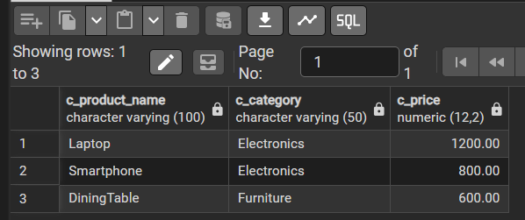
- Retrieve the most recent order placed by each customer using GROUP BY and ORDER BY.
SELECT o.c_order_id,
o.c_customer_id,
o.c_order_date,
o.c_total_amount
FROM t_orders o
WHERE o.c_order_date = (
SELECT MAX(o2.c_order_date)
FROM t_orders o2
WHERE o2.c_customer_id = o.c_customer_id
)
ORDER BY o.c_customer_id, o.c_order_date DESC;

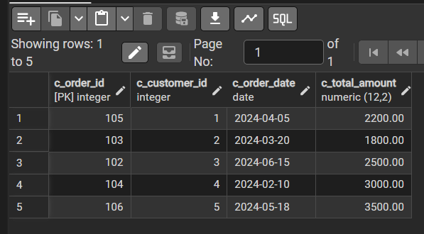

6. Set Operations
- Retrieve the names of customers who have placed orders and those who haven’t using a UNION of two queries.
-- ✅ Customers who have placed orders
SELECT c.c_customer_name AS customer_name,
'Placed Orders' AS status
FROM t_customers c
WHERE c.c_customer_id IN (
SELECT o.c_customer_id
FROM t_orders o
)

UNION

-- ✅ Customers who have NOT placed orders
SELECT c.c_customer_name AS customer_name,
'No Orders' AS status
FROM t_customers c
WHERE c.c_customer_id NOT IN (
SELECT o.c_customer_id
FROM t_orders o
);
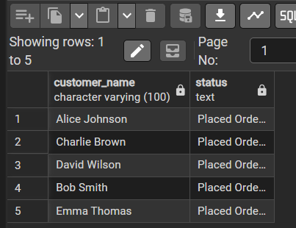
- Find customers who have placed orders for products in the 'Furniture' category using the INTERSECT set operation.
-- Customers who have placed orders
SELECT DISTINCT c.c_customer_name
FROM t_customers c
JOIN t_orders o
ON c.c_customer_id = o.c_customer_id

INTERSECT

-- Customers who ordered products in 'Furniture' category
SELECT DISTINCT c.c_customer_name
FROM t_customers c
JOIN t_orders o
ON c.c_customer_id = o.c_customer_id
JOIN t_order_details od
ON o.c_order_id = od.c_order_id
JOIN t_products p
ON od.c_product_id = p.c_product_id
WHERE p.c_category = 'Furniture';
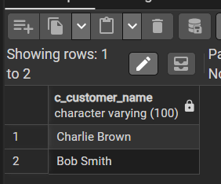
- List customers who have placed orders, but exclude those whose total order amount is less than ₹2000 using the EXCEPT set operation.
-- ✅ Customers who have placed orders
SELECT DISTINCT c.c_customer_name
FROM t_customers c
JOIN t_orders o
ON c.c_customer_id = o.c_customer_id

EXCEPT

-- ❌ Customers whose total order amount is less than ₹2000
SELECT c.c_customer_name
FROM t_customers c
JOIN t_orders o
ON c.c_customer_id = o.c_customer_id
GROUP BY c.c_customer_name
HAVING SUM(o.c_total_amount) < 2000;
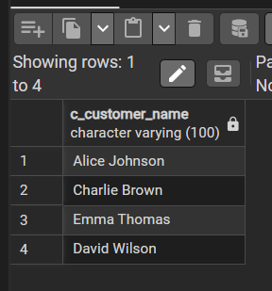

7. Joins and Subqueries
- Retrieve customer names along with their order IDs and product names using an inner join of Customers, Orders, and OrderDetails.
SELECT c.c_customer_name,
o.c_order_id,
p.c_product_name
FROM t_customers c
INNER JOIN t_orders o
ON c.c_customer_id = o.c_customer_id
INNER JOIN t_order_details od
ON o.c_order_id = od.c_order_id
INNER JOIN t_products p
ON od.c_product_id = p.c_product_id
ORDER BY c.c_customer_name, o.c_order_id;
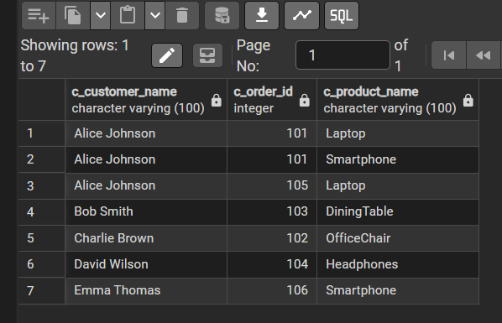
- Find the names of customers who have placed orders with a total amount greater than the average order amount using a subquery.
SELECT c.c_customer_name
FROM t_customers c
JOIN t_orders o
ON c.c_customer_id = o.c_customer_id
GROUP BY c.c_customer_name
HAVING SUM(o.c_total_amount) > (
SELECT AVG(c_total_amount)
FROM t_orders
);
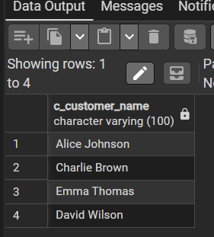
- Display the total quantity of products ordered by each customer using a join between Orders and OrderDetails, and group by customer name.
SELECT c.c_customer_name,
SUM(od.c_quantity) AS total_quantity_ordered
FROM t_customers c
JOIN t_orders o
ON c.c_customer_id = o.c_customer_id
JOIN t_order_details od
ON o.c_order_id = od.c_order_id
GROUP BY c.c_customer_name
ORDER BY c.c_customer_name;
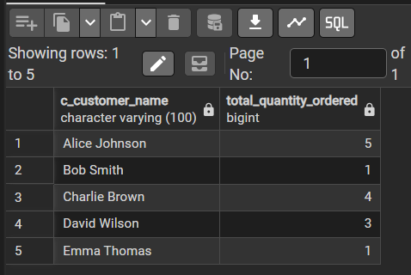
- List customers who have never placed an order using a left join and filtering for null order IDs.
SELECT c.c_customer_name
FROM t_customers c
LEFT JOIN t_orders o
ON c.c_customer_id = o.c_customer_id
WHERE o.c_order_id IS NULL;

- Retrieve product names along with the total revenue generated for each product using a join and aggregate functions.
SELECT p.c_product_name,
SUM(od.c_quantity * od.c_unit_price) AS total_revenue
FROM t_products p
JOIN t_order_details od
ON p.c_product_id = od.c_product_id
GROUP BY p.c_product_name
ORDER BY total_revenue DESC;

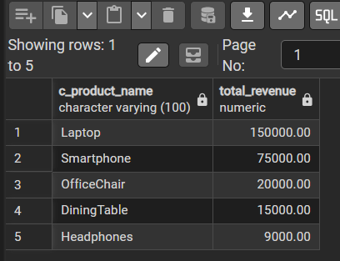
- Find pairs of customers from the same city using a self-join on the Customers table.
SELECT c1.c_customer_name AS customer1,
c2.c_customer_name AS customer2,
c1.c_customer_city AS city
FROM t_customers c1
JOIN t_customers c2
ON c1.c_customer_city = c2.c_customer_city
AND c1.c_customer_id < c2.c_customer_id
ORDER BY city, customer1, customer2;


